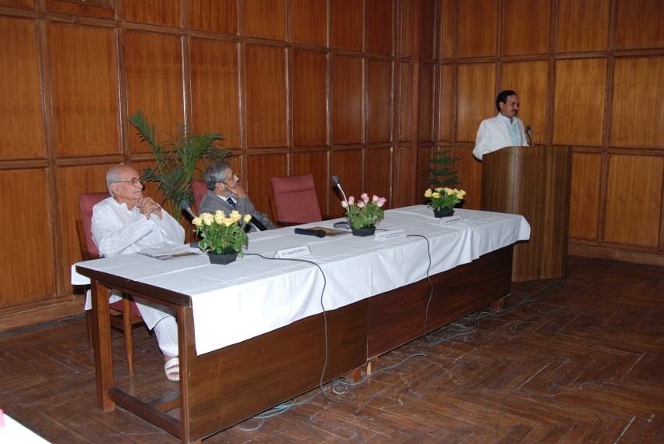

DR. MEHRA and HON. CHIEF JUSTICE M.B. LOKUR AT THE DELHI HIGH COURT ON 20TH MAY 2010

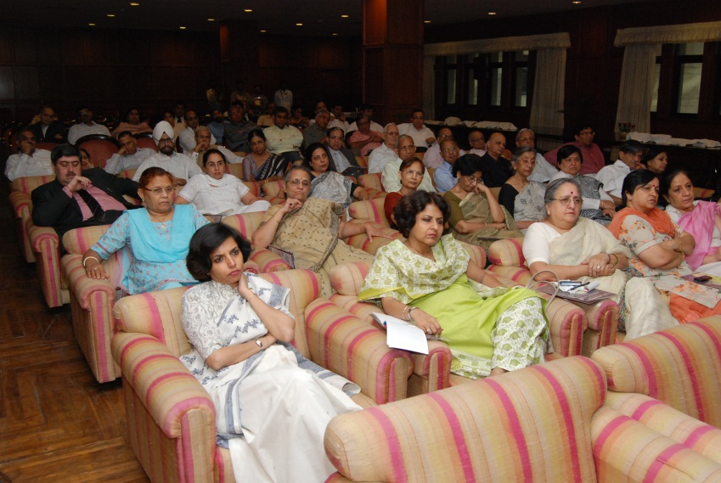

EMINENT JUDGES IN RAPT AUDIENCE

